* **Install python in Ubuntu:**
* **1.** Open terminal via Ctrl+Alt+T or searching for “Terminal” from app launcher. When it opens, run command to add the PPA:
* sudo add-apt-repository ppa:jonathonf/python-3.6
* *Type in your password (no visual feedback due to security reason) when it asks and hit Enter.*
* 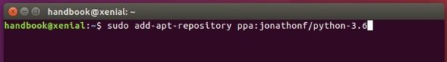
* **2.** Then check updates and install Python 3.6 via commands:
* sudo apt-get update
* sudo apt-get install python3.6
* Now you have three Python versions, use python command for version 2.7, python3for version 3.5, and/or python3.6 for version 3.6.1.
* 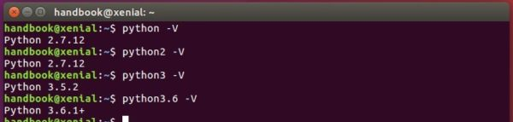
* **3.** To make python3 use the new installed python 3.6 instead of the default 3.5 release, run following 2 commands:
* sudo update-alternatives --install /usr/bin/python3 python3 /usr/bin/python3.5 1
* sudo update-alternatives --install /usr/bin/python3 python3 /usr/bin/python3.6 2
* Finally switch between the two python versions for python3 via command:
* sudo update-alternatives --config python3
* 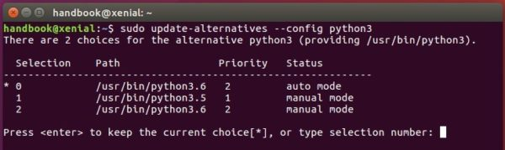
* After selecting version 3.6:
* python3 -V
* 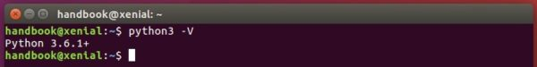
* **UPDATE:** due to this [bug](https://bugs.launchpad.net/ubuntu/+source/python3.6/+bug/1631367), gnome-terminal won’t launch after step 3, a workaround is running following commands to recreate the symlink:
* sudo rm /usr/bin/python3
* sudo ln -s python3.5 /usr/bin/python3